Hockey Canada
Coach 2 – Coach Level:
Workbook
Version 1.1, 2020

Table of Contents
Welcome! 1
Completing Your Logbook 2
Request for Evaluation at Coach 2 – Coach Level 3
Team Culture 4
Team 4
Yearly Schedule 5
Fair Play, Values and Ethics 6
My Personal Fair Play Code 6
Team Goals for Conduct and Behaviour 6
Parent Meeting Agenda 7
Prevention of Harassment, Abuse and Bullying 8
Emergency Action Plan 10
Game Logs 11
Game Log #1 11
Game Log #2 12
Game Log #3 13
Game Log #4 14
Game Log #5 15
Game Log #6 16
Game Log #7 17
Game Log #8 18
Practice Logs 19
Practice Log #1 19
Practice Log #2 20
Practice Log #3 21
Practice Log #4 22
Practice Log #5 23
Practice Log #6 24
Practice Log #7 25
Practice Log #8 26
Tips for the Coach and Mentor 27
The Mentor 27
Tips for the Mentor 28
Tips for the Coach 29

The Collection, Use, and Disclosure of Personal Information
The Coaching Association of Canada collects your NCCP qualifications and personal information and shares it with all NCCP partners according to the privacy policy detailed at www.coach.ca. By participating in the NCCP you are providing consent for your information to be gathered and shared as detailed in the privacy policy. If you have any questions or would like to abstain from participating in the NCCP please contact coach@coach.ca.

Copyright and government of Canada acknowledgement
2020 © Hockey Canada and Coaching Association of Canada. This document is copyrighted by the Coaching Association of Canada (2020) and its licensors. All rights reserved. Printed in Canada. No part of this publication may be reproduced, stored in a retrieval system or transmitted, in any form or by any means, without the express written permission of Hockey Canada and the Coaching Association of Canada. The National Coaching Certification Program (NCCP) is funded in part by the Government of Canada.

Welcome!
Congratulations on completing the in-class component for the Coach Stream Program of the National Coaching Certification Program. Through this one-day seminar you have had the opportunity to share your knowledge and experiences with your coaching peers. Your completion of the first component of the program demonstrates that you have a basic understanding of the following coaching concepts:
- Utilizing effective and efficient practice plans and yearly plans,
- Designing a communication plan and conducting effectively meetings with players and with parents,
- Defining a personal code of ethics to guide your coaching,
- Teaching key technical hockey skills and detecting and correcting player error in the execution of these fundamental skills.
You are now ready for the second component of the Coach Stream Program, which will challenge you to use these concepts within your teams practice and game environments. Along with putting these concepts into practice, you will also be expected to show proficiency in the following areas:
- Respond appropriately to the dynamics of competition within the game environment,
- Conduct effective on-ice practice sessions for that enhance skill acquisition in a safe and enjoyable environment.
This Coach Stream Logbook is a tool to guide your learning and help you gain the most from your coaching experiences during this hockey season. You are required to maintain this logbook throughout the season, and may choose to work with a mentor to reflect on the required tasks. Ultimately it is your Minor Hockey Association that will verify that the assigned tasks are completed. Although this logbook is to guide your personal development plan during this coursework, you are reminded that a logbook is an excellent tool designed to assist you in getting the most out of each hockey season.
With the many demands placed on the minor hockey coach, we hope the implementation of these key coaching concepts and skills will lead to a successful and enjoyable hockey season for you, your colleagues, and your players.

Yours in hockey,
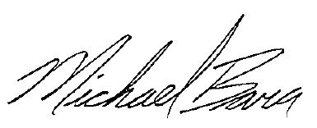
Michael Bara
Manager, Coaching Development, Hockey Canada

Completing Your Logbook
To be certified as a Coach Stream coach you are required to complete the following logbook in its entirety. The logbook consists of the following tasks:
Request for Evaluation at Coach 2 – Coach Level (p. 3) – This is the only page that you must submit as proof of completion of your logbook. The logbook is yours to keep; it should serve as a great planning tool for your future years in coaching. The Request for Certification at Coach 2 must be completed, initialed and signed by your association.
Team Culture (p. 4) – The team page is intended for you to have an opportunity to reflect on where your team is and what they might be like. This should be completed at or near the start of your season.
Yearly Schedule (p. 5) – Regardless of whether you are a head coach or assistant coach an important part of planning and organization is having a clearly laid out schedule for your parents and players. The team calendar should include:
- all scheduled games and practices, the time of the event and location
- all scheduled team functions including off ice training, team meetings, pizza party etc.
Fair Play, Values and Ethics (p. 6) – You should review the Fair Play codes found in your Hockey Canada Skills manual and add any other personal fair play codes you will follow. The team in consultation with you and the rest of the coaching staff should build team Code of Conduct. Examples of what this might include would be team rules, ramifications for breaking the rules, team expectations etc.
Parent Meeting Agenda (p. 7) – This must be a formal agenda, which you would hand out to your parents prior to a team meeting. The agenda must include details such as location of meeting, meeting time, topics to be covered and time for each topic, expected outcomes of meeting etc.
Prevention of Harassment, Abuse and Bullying (pp. 8-9) – This section will ask you to demonstrate your understanding of harassment and abuse issues and how you will plan to prevent them from occurring in your team environment. You should consider the sections on communications, the 6 step decision making model and the Speak Out material when completing this section.
Emergency Action Plan (p. 10) – The Emergency Action Plan should be completed for your team for your home arena.
Game Logs (pp. 11-18) – There are 8 Game Logs for you to complete. You should complete the top portion of the log prior to the start of each game and fill in the Games Notes after the completion of the game.
Practice Logs (pp. 19-26) – There are 8 practice logs to be completed. You are not expected to design drills but are expected to be able to outline the objectives of the practice, which drills you used from the Hockey Canada Skills Manual, track which players are attending practices and reflect on the practice. The intent of the comments area is for you to reflect on the practice, determine if you were successful in meeting your outcomes and what you would do differently the next time.

Request for Evaluation at Coach 2 – Coach Level
To obtain Coach 2 – Coach level certification through Hockey Canada and the National Coaching Certification Program,
- Fill in the Coach and Clinic Details portion of this form.
- Have a representative of your association complete the Task portion of this form.
- Submit this form with your logbook to the Technical Director of your provincial Member or Member Partner for evaluation.
Coach and Clinic Details
Name:
Phone: ________________________Email:
City: ______________________Province:
Clinic Location:
Clinic Date:
Mentor Coach:
(if applicable)
NCCP Number:

Task Signature of Association Representative
Completed Coaching Philosophy
Completed Parent Meeting
Completed Team Code of Conduct
Completed Yearly Schedule
Completed Prevention Plan
Completed 8 Game Logs
Completed 8 Practice Logs
Worked within the Fair Play codes

Name (please print):
Position in Association:
Signature:

Team Culture

Team
Name
Age & Level
Competitive Level
Coach
Assistants
Manager
Trainer

Strengths:
1.

2.

3.

Improvement Areas:
1.

2.

3.

Yearly Schedule
Attach a schedule of all practices, games and team activities. Attaching your team calendar through programs such as TeamSnap is acceptable.

Calendar Template:
October
Monday | Tuesday | Wednesday | Thursday | Friday | Saturday | Sunday

Calendar Example:
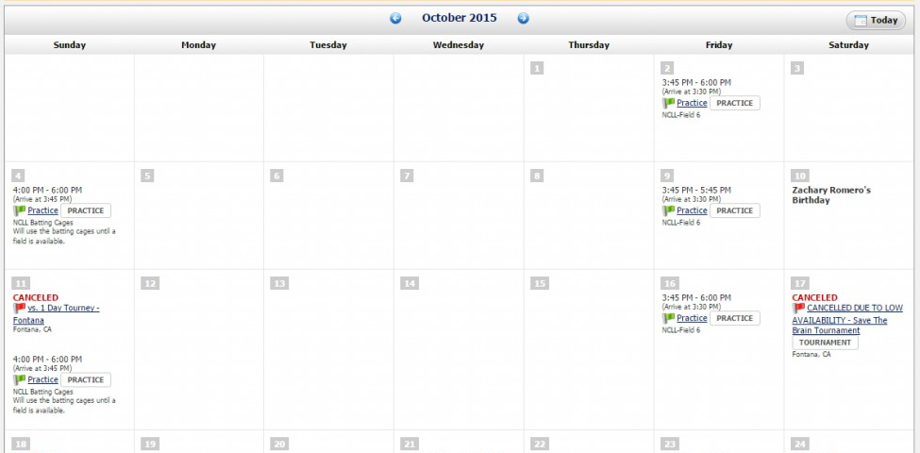

Fair Play, Values and Ethics

My Personal Fair Play Code

Team Goals for Conduct and Behaviour
(Should be completed with team)

What evidence will I see that our goals for conduct and behaviour are effective?

Parent Meeting Agenda
Insert agenda on this page.

Prevention of Harassment, Abuse and Bullying
Support articles on Prevention Guidelines and Frameworks for Intervention and Protection can be found at https://www.hockeycanada.ca/en-ca/hockey-programs/safety/essentials/downloads.
Using what you have learned in your pre-task assignments, classroom sessions and post task reading combined with your coaching skills complete a prevention plan for your team that will accomplish the following:
- A well-defined coaching philosophy.
- A code of conduct for your team.
- The creation of operational rules to address one topic within the post task reading on prevention.
- Scenario based activity outlining the steps on how you will address certain issues.
1. What is your coaching philosophy? How has it changed from the philosophy you wrote down during the pre-task?

2. Select one of the three following areas of supervision/prevention:
- Road Trips
- Dressing Room
- Congratulating Player on good play (physical contact)
Outline your prevention plan focusing on maintaining a safe environment within this area:

3. This season you have planned to meet with every player on the team at Christmas time to review their progress to date. You have just completed your last meeting of the evening and are accompanying the player to where they were to meet their ride. After waiting 15 minutes the ride has still not arrived.
Outline the steps/considerations that you would take as a coach to ensure that the meeting and subsequent pick-up process are completed within a Safe Environment:

Emergency Action Plan

Equipment Locations
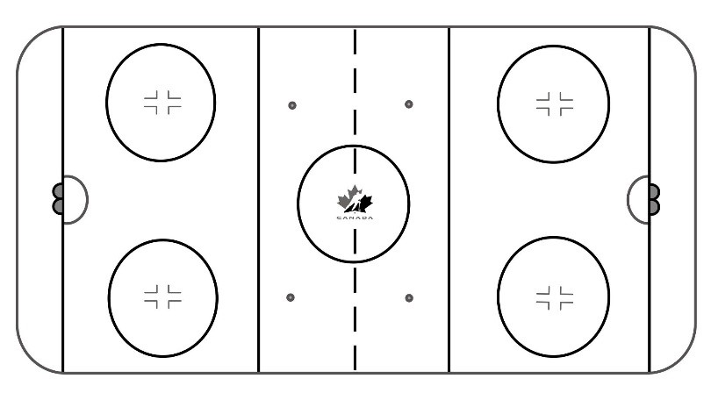
Please locate and identify areas on map. (e.g., first aid room, route for ambulance crew, telephone).

Emergency Telephone Numbers
Emergency Ambulance
Fire Dept. Hospital
Police General

1. Person in Charge
Most qualified person available with training in first aid and emergency control
Familiarize yourself with arena emergency equipment
Take control of an emergency situation until a medical authority arrives
Assess injury status of player
Name:

2. Call Person
Location of emergency telephone
List of emergency telephone numbers
Directions to arena
Best route in and out of arena for ambulance crew
Name:

3. Control Person
Ensure proper room to work for person in charge and ambulance crew
Discuss emergency action plan with:
Arena staff
Officials
Opponents
Ensure that the route for the ambulance crew is clear and available
Seek highly trained medical personnel (i.e., MD, nurse) if requested by person in charge
Name:

Game Logs

Game Log #1
Date: Location:
Opponent: Game Number:
Final Score
Opponent: Our Team:

FORWARDS DEFENSE GOALIES
_____ _____ _____ _____ _____ _____ _____
_____ _____ _____ _____ _____
_____ _____ _____ _____ _____
_____ _____ _____ _____ _____
_____ _____ _____

Team Notes:
What we did well as a team:

What we need to work on:

Game incidents – injuries, breaking team rules, penalties, etc.

Game Log #2
Date: Location:
Opponent: Game Number:
Final Score
Opponent: Our Team:

FORWARDS DEFENSE GOALIES
_____ _____ _____ _____ _____ _____ _____
_____ _____ _____ _____ _____
_____ _____ _____ _____ _____
_____ _____ _____ _____ _____
_____ _____ _____

Team Notes:
What we did well as a team:

What we need to work on:

Game incidents – injuries, breaking team rules, penalties, etc.

Game Log #3
Date: Location:
Opponent: Game Number:
Final Score
Opponent: Our Team:

FORWARDS DEFENSE GOALIES
_____ _____ _____ _____ _____ _____ _____
_____ _____ _____ _____ _____
_____ _____ _____ _____ _____
_____ _____ _____ _____ _____
_____ _____ _____

Team Notes:
What we did well as a team:

What we need to work on:

Game incidents – injuries, breaking team rules, penalties, etc.

Game Log #4
Date: Location:
Opponent: Game Number:
Final Score
Opponent: Our Team:

FORWARDS DEFENSE GOALIES
_____ _____ _____ _____ _____ _____ _____
_____ _____ _____ _____ _____
_____ _____ _____ _____ _____
_____ _____ _____ _____ _____
_____ _____ _____

Team Notes:
What we did well as a team:

What we need to work on:

Game incidents – injuries, breaking team rules, penalties, etc.

Game Log #5
Date: Location:
Opponent: Game Number:
Final Score
Opponent: Our Team:

FORWARDS DEFENSE GOALIES
_____ _____ _____ _____ _____ _____ _____
_____ _____ _____ _____ _____
_____ _____ _____ _____ _____
_____ _____ _____ _____ _____
_____ _____ _____

Team Notes:
What we did well as a team:

What we need to work on:

Game incidents – injuries, breaking team rules, penalties, etc.

Game Log #6
Date: Location:
Opponent: Game Number:
Final Score
Opponent: Our Team:

FORWARDS DEFENSE GOALIES
_____ _____ _____ _____ _____ _____ _____
_____ _____ _____ _____ _____
_____ _____ _____ _____ _____
_____ _____ _____ _____ _____
_____ _____ _____

Team Notes:
What we did well as a team:

What we need to work on:

Game incidents – injuries, breaking team rules, penalties, etc.

Game Log #7
Date: Location:
Opponent: Game Number:
Final Score
Opponent: Our Team:

FORWARDS DEFENSE GOALIES
_____ _____ _____ _____ _____ _____ _____
_____ _____ _____ _____ _____
_____ _____ _____ _____ _____
_____ _____ _____ _____ _____
_____ _____ _____

Team Notes:
What we did well as a team:

What we need to work on:

Game incidents – injuries, breaking team rules, penalties, etc.

Game Log #8
Date: Location:
Opponent: Game Number:
Final Score
Opponent: Our Team:

FORWARDS DEFENSE GOALIES
_____ _____ _____ _____ _____ _____ _____
_____ _____ _____ _____ _____
_____ _____ _____ _____ _____
_____ _____ _____ _____ _____
_____ _____ _____

Team Notes:
What we did well as a team:

What we need to work on:

Game incidents – injuries, breaking team rules, penalties, etc.

Practice Logs

Practice Log #1
Date: Time: Location:

FORWARDS DEFENSE GOALIES
_____ _____ _____ _____ _____ _____ _____
_____ _____ _____ _____ _____
_____ _____ _____ _____ _____
_____ _____ _____ _____ _____
_____ _____ _____

Practice Objectives (Insert a copy of your Practice Plan)

Drill #1: |  | Drill #4:
Drill Reflection (Was the drill effective, could players execute, modifications made, future use) |  | Drill Reflection (Was the drill effective, could players execute, modifications made, future use)
Drill #2: |  | Drill #5:
Drill Reflection (Was the drill effective, could players execute, modifications made, future use) |  | Drill Reflection (Was the drill effective, could players execute, modifications made, future use)
Drill #3: |  | Drill #6:
Drill Reflection (Was the drill effective, could players execute, modifications made, future use) |  | Drill Reflection (Was the drill effective, could players execute, modifications made, future use)

Practice Log #2
Date: Time: Location:

FORWARDS DEFENSE GOALIES
_____ _____ _____ _____ _____ _____ _____
_____ _____ _____ _____ _____
_____ _____ _____ _____ _____
_____ _____ _____ _____ _____
_____ _____ _____

Practice Objectives (Insert a copy of your Practice Plan)

Drill #1: |  | Drill #4:
Drill Reflection (Was the drill effective, could players execute, modifications made, future use) |  | Drill Reflection (Was the drill effective, could players execute, modifications made, future use)
Drill #2: |  | Drill #5:
Drill Reflection (Was the drill effective, could players execute, modifications made, future use) |  | Drill Reflection (Was the drill effective, could players execute, modifications made, future use)
Drill #3: |  | Drill #6:
Drill Reflection (Was the drill effective, could players execute, modifications made, future use) |  | Drill Reflection (Was the drill effective, could players execute, modifications made, future use)

Practice Log #3
Date: Time: Location:

FORWARDS DEFENSE GOALIES
_____ _____ _____ _____ _____ _____ _____
_____ _____ _____ _____ _____
_____ _____ _____ _____ _____
_____ _____ _____ _____ _____
_____ _____ _____

Practice Objectives (Insert a copy of your Practice Plan)

Drill #1: |  | Drill #4:
Drill Reflection (Was the drill effective, could players execute, modifications made, future use) |  | Drill Reflection (Was the drill effective, could players execute, modifications made, future use)
Drill #2: |  | Drill #5:
Drill Reflection (Was the drill effective, could players execute, modifications made, future use) |  | Drill Reflection (Was the drill effective, could players execute, modifications made, future use)
Drill #3: |  | Drill #6:
Drill Reflection (Was the drill effective, could players execute, modifications made, future use) |  | Drill Reflection (Was the drill effective, could players execute, modifications made, future use)

Practice Log #4
Date: Time: Location:

FORWARDS DEFENSE GOALIES
_____ _____ _____ _____ _____ _____ _____
_____ _____ _____ _____ _____
_____ _____ _____ _____ _____
_____ _____ _____ _____ _____
_____ _____ _____

Practice Objectives (Insert a copy of your Practice Plan)

Drill #1: |  | Drill #4:
Drill Reflection (Was the drill effective, could players execute, modifications made, future use) |  | Drill Reflection (Was the drill effective, could players execute, modifications made, future use)
Drill #2: |  | Drill #5:
Drill Reflection (Was the drill effective, could players execute, modifications made, future use) |  | Drill Reflection (Was the drill effective, could players execute, modifications made, future use)
Drill #3: |  | Drill #6:
Drill Reflection (Was the drill effective, could players execute, modifications made, future use) |  | Drill Reflection (Was the drill effective, could players execute, modifications made, future use)

Practice Log #5
Date: Time: Location:

FORWARDS DEFENSE GOALIES
_____ _____ _____ _____ _____ _____ _____
_____ _____ _____ _____ _____
_____ _____ _____ _____ _____
_____ _____ _____ _____ _____
_____ _____ _____

Practice Objectives (Insert a copy of your Practice Plan)

Drill #1: |  | Drill #4:
Drill Reflection (Was the drill effective, could players execute, modifications made, future use) |  | Drill Reflection (Was the drill effective, could players execute, modifications made, future use)
Drill #2: |  | Drill #5:
Drill Reflection (Was the drill effective, could players execute, modifications made, future use) |  | Drill Reflection (Was the drill effective, could players execute, modifications made, future use)
Drill #3: |  | Drill #6:
Drill Reflection (Was the drill effective, could players execute, modifications made, future use) |  | Drill Reflection (Was the drill effective, could players execute, modifications made, future use)

Practice Log #6
Date: Time: Location:

FORWARDS DEFENSE GOALIES
_____ _____ _____ _____ _____ _____ _____
_____ _____ _____ _____ _____
_____ _____ _____ _____ _____
_____ _____ _____ _____ _____
_____ _____ _____

Practice Objectives (Insert a copy of your Practice Plan)

Drill #1: |  | Drill #4:
Drill Reflection (Was the drill effective, could players execute, modifications made, future use) |  | Drill Reflection (Was the drill effective, could players execute, modifications made, future use)
Drill #2: |  | Drill #5:
Drill Reflection (Was the drill effective, could players execute, modifications made, future use) |  | Drill Reflection (Was the drill effective, could players execute, modifications made, future use)
Drill #3: |  | Drill #6:
Drill Reflection (Was the drill effective, could players execute, modifications made, future use) |  | Drill Reflection (Was the drill effective, could players execute, modifications made, future use)

Practice Log #7
Date: Time: Location:

FORWARDS DEFENSE GOALIES
_____ _____ _____ _____ _____ _____ _____
_____ _____ _____ _____ _____
_____ _____ _____ _____ _____
_____ _____ _____ _____ _____
_____ _____ _____

Practice Objectives (Insert a copy of your Practice Plan)

Drill #1: |  | Drill #4:
Drill Reflection (Was the drill effective, could players execute, modifications made, future use) |  | Drill Reflection (Was the drill effective, could players execute, modifications made, future use)
Drill #2: |  | Drill #5:
Drill Reflection (Was the drill effective, could players execute, modifications made, future use) |  | Drill Reflection (Was the drill effective, could players execute, modifications made, future use)
Drill #3: |  | Drill #6:
Drill Reflection (Was the drill effective, could players execute, modifications made, future use) |  | Drill Reflection (Was the drill effective, could players execute, modifications made, future use)

Practice Log #8
Date: Time: Location:

FORWARDS DEFENSE GOALIES
_____ _____ _____ _____ _____ _____ _____
_____ _____ _____ _____ _____
_____ _____ _____ _____ _____
_____ _____ _____ _____ _____
_____ _____ _____

Practice Objectives (Insert a copy of your Practice Plan)

Drill #1: |  | Drill #4:
Drill Reflection (Was the drill effective, could players execute, modifications made, future use) |  | Drill Reflection (Was the drill effective, could players execute, modifications made, future use)
Drill #2: |  | Drill #5:
Drill Reflection (Was the drill effective, could players execute, modifications made, future use) |  | Drill Reflection (Was the drill effective, could players execute, modifications made, future use)
Drill #3: |  | Drill #6:
Drill Reflection (Was the drill effective, could players execute, modifications made, future use) |  | Drill Reflection (Was the drill effective, could players execute, modifications made, future use)

Tips for the Coach and Mentor

The Mentor

Areas coach mentors may have to deal with
Coach mentors will be expected to draw upon their experience to offer guidance and encouragement to a developing coach. Some of the areas they may address in this process include:
- The importance of quality coaching for the holistic development of athletes and sport programs.
- The coaching process: what is competent coaching?
- Values and attitudes that show respect for the athletes and sport as an institution.
- A framework to assist the coach to become critically reflective and make enlightened decisions.
- A blend of information on the art and the science of coaching.
- The human dimension of coaching.
- Technical/tactical information to foster the coach’s knowledge.
- Goals necessary for advancement.

Responsibilities of a coach mentor
A coach mentor gives the coach:
- Vision and insight.
- Advice and counsel.
- Support and encouragement.
- Self-confidence and an improved self-esteem.
- A safer environment for taking risks.
- Crisis or failure control plans.
- Insight on the games of the sport culture.
- A solid point of reference as a role model.
- Tasks that will challenge his or her current beliefs.
- Opportunities to reflect critically on issues and situations make objective decisions and develop a strong work ethic.
- Constructive feedback and critical analysis.

Tips for the Mentor
“We continue to grow when we help others grow and develop.”

Setting up a meeting schedule and sticking to it!
It is critical to determine how much time will be spent in the mentoring process. Once this has been determined, a schedule of meetings, observations, etc. will assist both parties of meeting their obligation.

Picking up the phone!
A quick phone call can add a lot of reinforcement to the coach, as well as the relationship. Phone calls (emails) are especially recommended at the checkpoint times. These are dates you have determined to be a good time for checking on the coach’s progress on his/her activity plans.

Listening and asking a lot of questions!
Good questioning techniques take a lot of practice. Use them as a point of reference to promote critical reflection in the coach.

Keeping the coach moving!
If a coach mentor assigns an activity or project, follow up regular to ensure that the coach is working through the activity. Provide positive encouragement to guide and motivate the coach.
When a commitment to checkpoints, schedules, calls, gathering information, or writing correspondence is made, follow through and try to do it in the time specified. Trust is a very big factor in building a strong mentoring relationship.

Promoting!
Promote your coach, as well as the concepts of a mentoring program. You are the best advocate of the mentoring program and the success of the coach!

Record keeping!
Use a journal to keep all your notes and ideas about your coach’s progress. It will help to keep everything together whenever you are meeting and it helps you to keep track of where you’ve been. It will be a great chronicle of your coach’s coaching development.

Tips for the Coach
“The first step in growth and development is having the desire to do so”.

Be on time!
Being late for a meeting is inconsiderate and shows a lack of organization and respect. Try to maintain a mutually agreed upon schedule and if a conflict should occur, notify the mentor as soon notice as possible.

Accept the mentor’s advice!
If there is disagreement with the advice or counsel, ask questions and let the mentor know of about the hesitation. It may be as simple as not clearly understanding or a lack of information and background. Communication, honesty and trust are the keys to building this type of relationship.

Complete assignments on time!
The self-evaluations and reports to all the different types of learning and career enhancing activities should have deadlines and checkpoints. Maintain a schedule that is realistic and yet ambitious. When mentoring meetings take place, it should be a meeting that moves both parties forward, not playing catch-up.

Be honest!
Share concerns, fears, joys and successes. A coach mentor needs to understand and support the coach with all the information available. Communication is at the very heart of the relationship.

Maintain a journal!
A journal is an ongoing resource and record of all activities, thoughts, questions, and growth. It will also assist in keeping all records of the mentoring partnership in one place, not only for current information, but also as a chronicle of personal growth.

Provide a coaching history!
A mentor does not want to be redundant or waste time and energy. Provide all the necessary background to assist in making decisions about priority training needs and the type of observation and feedback that will be the most useful.

Ask questions and listen carefully!
A coach mentor has a wealth of knowledge and experience. The coach should take advantage of the opportunity to learn from the coach mentor’s resource base.

